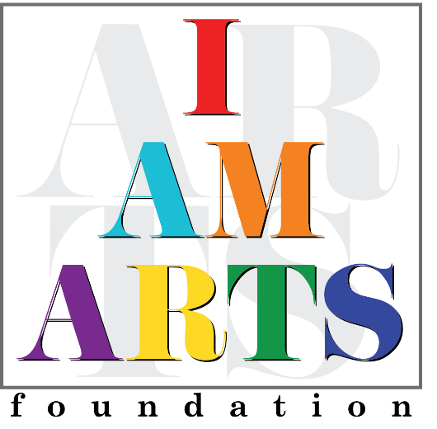

For almost twenty years Sonya Tate-Smith has been an educator and advocate for children. She currently works in Fulton County Schools as a Literacy Coach but has spent many years educating students with special needs and those experiencing academic deficits in a variety of areas. She has a Bachelor’s degree in Psychology from Howard University and a Masters’ degree in Learning and Behavior Disorders from Georgia State University. Mrs. Tate-Smith’s philosophy on learning and life hinges on the idea that exposure, educating and loving the whole child can awaken a world of possibilities. She has served as a parent contact for both the Prodigy and Junior Companies for several years and now is happy to serve on the I AM ARTS board as a Parent Liaison.

